**COMP 3069 -- Computer Graphics**

**Project**

**Release Date:** *3****1 October 2018***

**(Weightage to final grade is 70%.)**

## Description

The project requires you to create a 3D scene by yourself. You may decide the content of the scene you create, which could be a scene from real world, or a virtual scene created by your imagination. The purpose of this proposed project is for you to demonstrate your knowledge of computer graphics techniques taught in the lectures and labs. We also give credits for your creative ideas being contributed in your project. Some example 3D scene are given for your reference as follows:

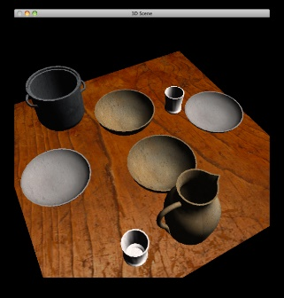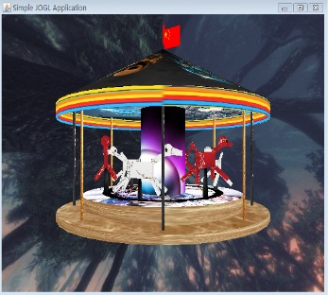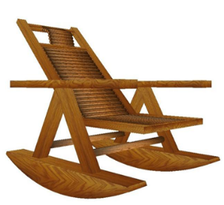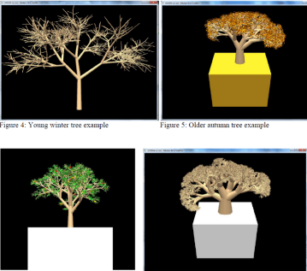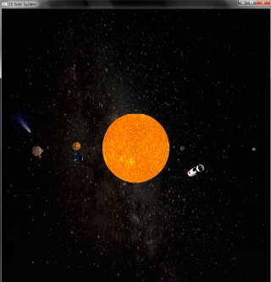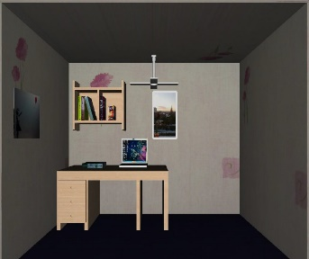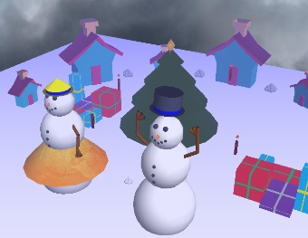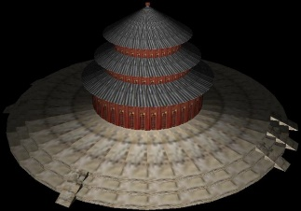

You are required to create a 3D scene withthe majority of the following items:

* + Several3D models,
  + Transformation of models (scaling, translating, rotating),
  + Different viewpoint, and/or animations,
  + Texturing –you need to employ texture to make some models look more realistic.
  + Lighting – you should apply lighting effect in your scene.
  + Some your own interesting creative ideas.

## Proposal

In the first two weeks, you need to submit **2-page** draft proposal of what you want to do for creating the 3D scene (although you could deviate a bit when you are progressing in doing your project).

**(3% marks)**

**Due date: 4:00pm, 13 November 2018**

**File name: CG_2018_ IDNUMBER_PROPOSAL.pdf**

## Interim Report

Then after a couple of weeks, you need to submit a **6-page** progress report telling us the progress of your program,what tasks are remained to be done. The purpose of this interim report is to remind you *NOT* to do the whole project until the very last minute. So please try to do *MORE* programming up to this stage.

**(7% marks)**

**Due date: 4:00pm, 27November 2018**

**File name: CG_2018_ IDNUMBER_INTERIM.pdf**

## Full Program and Report

And then after another couple of weeks, you need to submit a zip file including: full report, and source code.

* + Full report: (**around 10 pages**)

Describing how to use your program, how you meet the requirements of the project, and your creative ideas contributed in creating the scene. Note that in your report, you *MUST* include a screenshot picture of your full scene you produced in your program.

**(15% marks)**

* + Source Code:

Apart from the requirements described in the Description section, some minor credits **(5%)** are given for accounting for the readability, good structure and good style of the source code you write.

**(65% marks)**

**Due date: 4:00pm, 16 December 2018**

**File name:**

**Zip file: CG_2018_ IDNUMBER_PROJECT.zip,** which contains the following files**:**

**1. Full report: CG_2018_IDNUMBER_REPORT.pdf**

**2. Souce Code: Note: Free to name the files(“.cpp”, “.h”, etc)**

## In-class Demo of Your Program

Each of you need to do an in-class demo of around 5 to 6 minutes to present what the program you wrote can display. You would belong to either group 1 or group 2. And the presentation order of the students for each group is listed as follows.

**Group 1: Time: 4:00pm – 6:00pm in the class, 17 December 2018**

**Group 2: Time: 12:00pm – 3:00pm in the class, 18 December 2018**

**(10% marks)**

Group 1:

|  |  |  |
| --- | --- | --- |
|  | Name | Student ID |
| 1 | Nikita Saprinskiy | 10310162 |
| 2 | Yunyi LEI | 16512869 |
| 3 | Kan Liu | 16515770 |
| 4 | Zexi SONG | 16515777 |
| 5 | Jiaying SUN | 16515778 |
| 6 | Junhao ZHANG | 16515788 |
| 7 | Haolin XUE | 16518196 |
| 8 | Wenpeng CHENG | 16518305 |
| 9 | Wenyuan YAN | 16518502 |
| 10 | Yuhang YING | 16518515 |
| 11 | Xiaoyu XIA | 16518645 |
| 12 | Shiqi BAI | 16518692 |
| 13 | Yuhan BIAN | 16518694 |
| 14 | Like CHEN | 16518695 |
| 15 | Kanlin CHENG | 16518696 |
| 16 | Yue DAI | 16518697 |
| 17 | Heyan GAO | 16518698 |
| 18 | Longyue GAO | 16518699 |
| 19 | Mingyang HUANG | 16518707 |
| 20 | Zihan JIAO | 16518709 |

Group 2:

|  |  |  |
| --- | --- | --- |
| 21 | Nan LI | 16518711 |
| 22 | Shanshan LI | 16518712 |
| 23 | Jiyao LV | 16518717 |
| 24 | Mingyu MA | 16518718 |
| 25 | Hejia QIU | 16518720 |
| 26 | Yi SHEN | 16518723 |
| 27 | Ziyao WANG | 16518728 |
| 28 | Shuang WU | 16518729 |
| 29 | Ziqi WU | 16518730 |
| 30 | Binghong YU | 16518735 |
| 31 | Shiying YU | 16518736 |
| 32 | Zhuping Yu | 16518737 |
| 33 | Mawentai ZENG | 16518739 |
| 34 | Jialu ZHANG | 16518740 |
| 35 | Xiang ZHANG | 16518743 |
| 36 | Zhengchun ZHAO | 16518746 |
| 37 | Botian ZHENG | 16518747 |
| 38 | Tingting ZHU | 16518749 |
| 39 | Xiaofei GUO | 16518796 |
| 40 | Yangsha XIE | 16518816 |
| 41 | Ziwei ZHANG | 16518822 |
| 42 | Chang ZHAO | 16518970 |
| 43 | Yuanliang GAO | 16519005 |
| 44 | Zhihao YING | 16519067 |
| 45 | Guanyu Zong | 16519656 |